ERD

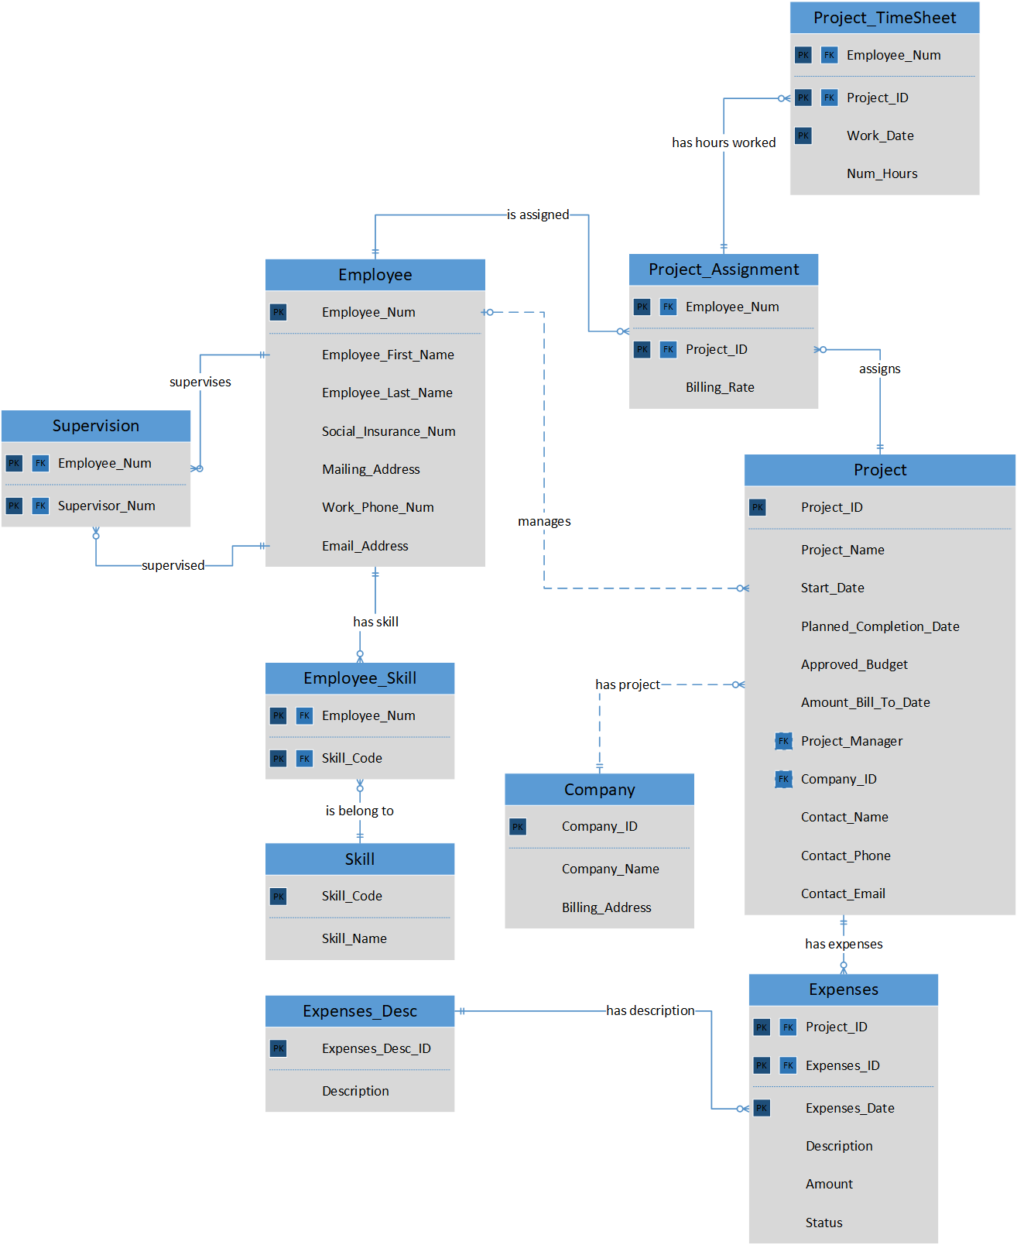

Assumptions

* Project_Manager attribute of Project entity references to the Employee_Num of Employee entity.
* Each project has unique ID
* Each Client Company has unique ID
* The employee that is assigned as project manager must has “Project Management” skill. That means the Project_Manager attribute of the Project entity must be the Employee_Num that occurs in Employee_Skill entity with Skill_Code of “Project Management” record. For example: Employee Number 1001 is project manager of Project ID 2002. The Skill code of “Project Management” is 3003. The record (Employee number =1001, Skill code = 3003) must be in Employee_Skill
* The employee that works for the specific project can enter the number of hours worked for the specific date once only. So, (Employee_Num, Project_ID, Work_Date) is composite primary key of Project_TimeSheet. Project_TimeSheet is weak entity.
* The number of hours worked for the project or employee can retrieved from querying the Project_TimeSheet entity.
* The total cost of the budget can be retrieved from number of hours worked, billing_rate and from the expenses entity. So, the Amount_Bill_To_Date is derived attribute.
* The status of Expenses is ‘S’ for submitted, ‘A’ for approved, ‘B’ for billed.
* Expenses_Desc stores the standard expense descriptions. Expenses_Desc has the “Other” record. If that record is in Expenses_ID of Expenses entity, the Description attribute is entered manually to describe the specific expenses.